Chapter 11, Problem 68.

Compute the complex power supplied by the current source in the series RLC circuit in Fig. 11.87.

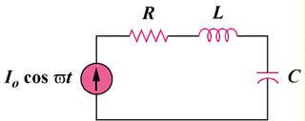

Figure 11.87
For Prob. 11.68.

